Template for the International Journal of Educational Projects

C. A. M. dos Santos¹*, M. A. C. Pereira¹, M. A. M. Barreto¹, E. C. Romão¹, E. F. dos Santos¹, C. Z. de Carvalho Neto², M. A. de Souza^{3,4}, and M. A. A. Monteiro⁵

¹Programa de Pós-Graduação em Projetos Educacionais de Ciências, Escola de Engenharia de Lorena,
Universidade de São Paulo, Lorena, SP – Brazil, 12.602-810.
²Instituto Galileo Galilei para a Educação, Florianópolis, SC – Brazil, XX.XXX-XXX
³Mestrado Profissional em Educação, Universidade de Taubaté, Taubaté, SP – Brazil, 12.020-040.
⁴Programa de Pós-graduação em Gestão e Desenvolvimento Regional, Centro Universitário do Sul de Minas,
Varginha, MG – Brazil, 37.031-099.
⁵Faculdade de Engenharia de Guaratinguetá, Universidade de Estadual Paulista “Júlio de Mesquita Filho”,
Guaratinguetá, SP – Brazil, 12.516-410.

*Corresponding author’s e-mail: ijep_ppgpe@usp.br
Submitted 10 April 2020 / Accepted 10 April 2020 / Available online 10 April 2020
doi.org/00.0000/ijep0-2020-1

ABSTRACT

This text describes the procedures for preparing manuscripts to be submitted to the International Journal of Educational Projects. Filling in this template either in Portuguese or in English is the only way to submit a manuscript to this journal. The structure of the manuscript is described in detail and must be followed carefully by the authors. The manuscript must include an Abstract, Keywords, Introduction, Results and discussion, Final remarks, and References. The Abstract should not exceed 100 words and only 3 Keywords should be included. Methodology as well as Results and discussion sections can have different titles and be divided into subsections.

Keywords: Template; Educational; Journal.

1. Introduction
During the last few decades, Brazil has published an extensive collection of scientific journals in diverse subject areas. A brief search in the beginning of 2020, using the words education or teaching in the title of the journals on the list Novo Qualis [1], related to the education and teaching areas of the CAPES Agency [2], indicated the existence of approximately 375 Brazilian journals. An inspection of the active journal webpages from the search (301) found that the majority of journals (86.4%) publish articles only in Portuguese, 7.3% of the journals publish in Portuguese and English languages, while only 6.3% accept to publish papers in English. Therefore, this situation makes it difficult to divulge and the internationalization process of the teaching and education research done in Brazil.
To facilitate the publication process and join other academic journals, which publish in both languages, and to establish an accessible publication process for Brazilian research written in high quality English, while maintaining the Portuguese versions available to a broad public of Brazilian educators, the International Journal of Educational Projects (IJEP) has been launched.
Editorial Council and Board of the International Journal of Educational Projects (IJEP) intend to publish original short papers, with a limit between 4 to 6 pages, dedicated to teaching and educational practices in all areas of knowledge. The issues will not be published on a monthly or per semester basis, but by the number of accepted papers. The editorial board understands that the quality of this journal will be positively impacted by this approach.
The scope of this journal deals mainly with the following topics:
i) Active Learning Strategies;
ii) Inter and Transdisciplinarity;
iii) Basic Education;
iv) Undergraduate and Graduate Programs;
v) Distance Learning Education;
vi) Case Studies in Teaching and Education;
vii) Experiences in Teaching and Learning;
viii) Public Policies in Education;
ix) Education Management; and
x) Others related topics.
Several examples of publications related to the above scope are shown in the Reference section.
The main focus of the journal is to publish original papers based upon applied experiences developed in educational environments, such as Schools, Colleges, Universities, and Public Educational Agencies.
The following sections are devoted to guide authors to prepare manuscripts to submit to IJEP.

2. Methodology
The guidelines for completing this template are listed below. Read each subsection carefully and follow instructions. The appropriate font is Times New Roman, size 11. Structure the text in two well- distributed columns. Adjust the text and Figures, Tables, and Charts to create visual alignment for easier reading.

2.1. Figures
Figures should be numbered consecutively in accordance with their location in the text. Captions should be placed below the figure. Keep in mind that the resolution of the Figures will be evaluated during the review process. Pictures which show people’s faces must not appear in the manuscript (for instance see Figure 2 of reference [4]).
Figure must fill the entire horizontal space available. An example is shown in Figure 1.

2.2. Tables and Charts
Number Tables and Charts consecutively in accordance with their appearance in the text. Place the Table and Chart captions above them. Examples are shown in Table 1 and Chart 1. The captions must be single spaced and the font size 10. Center the number and the words inside the Tables and Charts. If you need a wider Table or Chart, break the section as shown in Chart 1.
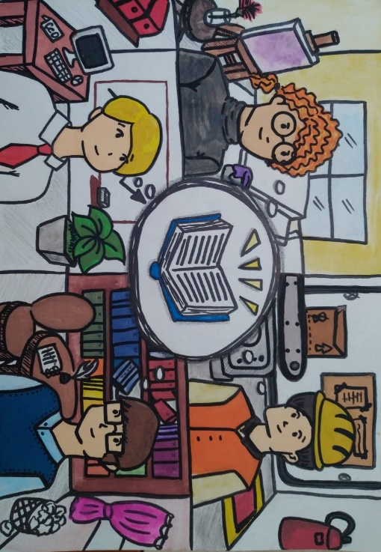
Figure 1. Four professionals thinking about a book. Reported in reference [3].

Table 1. Number of students who came to the gamification classes. Adapted from Reference [4].
Class | 1 | 2 | 3 | 4 | 5 | 6 | 7
No. | 25 | 26 | 23 | 27 | 27 | 22 | 21
% | 92.6 | 96.3 | 85.2 | 100 | 100 | 81.5 | 77.8

2.3. Captions
Do not abbreviate the Tables, Figures, Charts, and Equations, in the caption or in the text. See subsections 2.1 and 2.2 for the procedures to place the captions in the right positions.

Chart 1. Soft skills acquired by students during the application of an interdisciplinary project. Adapted from Reference [4].
Project Management | Team work | Personal Development | Communication
Research activity  Decision making ability  Organizational ability  Time management | Autonomy  Initiative  Responsibility  Leadership  Problem resolution  Interpersonal relationship  Conflict management | Creativity/Originality  Critical thinking  Auto Evaluation  Autoregulation | Oral communication  Written communication

2.4. Citations
References must be cited in the text consecutively and placed at the end of the manuscript, as shown in the Reference section. For an example, see the citation for this IJEP reference [3]. Use font size 10 for citations.
The examples reported in this section should include papers [3-6], books [7], MSc or PhD theses [8], private communications [1], and webpages [2]. The DOI or link for each reference listed must correctly connect the reader to the article. Authors should avoid referencing webpages, such as blogs, newspapers, and other virtual resources which are no longer available.
Following these procedures will facilitate citation and allow readers easy access to the references listed in the academic article.

2.5. Manuscript submission
To submit manuscripts to this journal, the template must be completed correctly. Manuscripts may be submitted in Portuguese or in English.
Manuscripts must be original and neither published nor considered for publication in other journals or other venues.
Before submitting a manuscript, authors must be aware that the publication of a particular issue of the journal will not be related to any periodicity but the number of accepted manuscripts. Each issue will be launched online with at least 12 accepted papers. This is believed to improve the quality of the published materials. If authors rush to publish their manuscript, IJEP may not be the most appropriate journal for publication.
Once the manuscript is properly formatted in this template, the corresponding author will submit to the following webpage: www.ppgpe.eel.usp.br/ijep.

2.6. Evaluation process
Manuscripts submitted to the IJEP will be evaluated, at least, by two ad hoc peer reviewers, chosen by one of the journal Editors. Once authors submit their manuscript, Editors will assume that authors fully agree with the ad hoc process adopted by IJEP.
The Editors will report the decision of acceptance or rejection based upon the reviewers’ judgments. If the manuscript is rejected, the author will have one opportunity to ask for a reconsideration.

2.7. Proofreading
If a Portuguese manuscript is accepted after the ad hoc evaluation process, the manuscript should be translated into English by a native speaker.
Accepted English manuscripts submitted by a non-native English author will be sent to English proofreading. Furthermore, accepted English manuscripts submitted by either native or non-native speakers will be translated into Portuguese.
The authors will be responsible for all expenses related to translation and proofreading processes, either for Portuguese or English languages. Thus, authors must be aware and agree with the payment of those services, which will depend upon the number of words in each manuscript. Up-to-date online service options will be available on the IJEP webpage.

Once the editors have completed the proofreading process, the article will be published in the online journal. Each issue will be published online with at least 12 accepted papers.

3. Results and discussion
This section contains the results and discussion of the manuscript.

4. Final remarks
Write the final remarks about the study in this section.

Acknowledgements
This is based on support by FAPESP (00/0000-0) and 00/0000-0), CNPq (Proc. 00000/0000), and CAPES (001).
Authors thank Drs. John Smith and Sally Jones for support.

References
[1] Novo QUALIS 2017-2020, Private Communication. CAPES 2019.
[2] CAPES Agency.
www.capes.gov.br
[3] C. A. M. dos Santos, Int. J. Educ. Proj. 0 (2020) 1–3.
doi.org/00.0000/ijep0-2020-1
[4] C. A. M. dos Santos, M. A. C. Pereira, M. A. de Souza, J. P. M. Dias, and F. S. Oliveira. Int. J. Social Science Studies 8 (2020) 15–23.
doi.org/10.11114/ijsss.v8i2.4693
[5] M. A. de Souza, L. L. Criado, C. A. M. dos Santos, and P. D. E. B. S. C. O. Monteiro. Under review.
[6] M. A. C. Pereira, M. A. M. Barreto, and M. Pazeti. Production 27 (2017) e20162238.
doi.org/10.1590/0103-6513.223816
[7] C. Z. de Carvalho Neto. Educação 4.0: princípios e práticas de inovação em gestão e docência. ISBN: 9788586159145. Laborciencia. 2018.
inovae4.com.br/produto/livro-educacao-4-0
[8] L. Carneiro/I. C. A. Fazenda. Interdisciplinaridade escolar: proposta didática de um modelo para a educação. PhD. 2018. PUC-SP, São Paulo, Brazil.
tede2.pucsp.br/handle/handle/21539

